Rowe Technology, Inc.

Pulse Wave User Guide

Pulse Wave 0.0.3

Trademark Information

Rowe Technology, Inc. Pulse, the Rowe Technology, Inc. Pulse logo design, Rowe Technology, Inc. the Rowe Technology, Inc. logo design are trademark of Rowe Technology, Inc in the United States and various other countries.

All other trademarks are the property of their respective owners.

Patent Information

The accompanying product is protected by one or more U.S. and foreign patents and/or pending patent applications held by Rowe Technology, Inc.

© 2011 Rowe Technology, Inc. All rights reserved.

Rowe Technology, Inc.

12655 Danielson Court, Suite 306

Poway, CA 92064

USA

No part of this document may be reproduced or transmitted in any form or by any means, electronic or mechanical, for any purpose, without the express written permission of Rowe Technology, Inc. Under the law, reproducing includes translating into another language or format. As between the parties, Rowe Technology, Inc. retains title to, and ownership of, all proprietary rights with respect to the software contained within its products. The software is protected by United States copyright laws and international treaty provision. Therefore, you must treat the software like any other copyrighted material (e.g. a book or sound recording). Every effort has been made to ensure that the information in this manual is accurate. Rowe Technology, Inc. is not responsible for printing or clerical errors. Information in this document is subject to change without notice.

|  |  |  |  |  |
| --- | --- | --- | --- | --- |
| **Date** | **Author** | **Rev** | **App Rev** | **Comments** |
| 12/31/2014 | Rico | A | 0.0.1 | Initial Writing. |
| 02/19/2015 | Rico | B | 0.0.2 | Add WaVector navigation button. |

About this Guide

|  |  |
| --- | --- |
|  | The Rowe Technology, Inc. Pulse Wave User Guide is for administrators and users of the Rowe Technology, Inc. Pulse Wave software, Acoustic Doppler and Imaging technologies.  The following related documents for the Rowe Technology, Inc. instruments are available:   * RTI ADCP DVL User Guide * Prime User Manual |

Contents

Overview 13

Quick Start 14

Navigation Menu 16

1. Back Button 16

2. Configure Button 16

3. Recover Button 16

4. View Button 16

5. Terminal Button 16

6. Firmware Button 16

7. Compass Cal Button 17

8. WaVector Button 17

Configure Page 18

Wave Controls 18

1. Stop/Wakup ADCP Button 19

2. Read ADCP Commands 19

3. Format ADCP SD Card 19

4. Send Commands to ADCP 20

5. Set ADCP Time 20

6. Read ADCP Time 20

7. Set ADCP Start Time 20

8. Zero Pressure Sensor 20

9. Start ADCP 20

Wave Setup 21

1. Read Commands 21

2. Default Subsystem Options 22

3. Set Defaults 22

4. Serial Output 22

5. Recording 22

6. Transducer Depth 22

7. PSENS Height 22

8. Salinity 23

9. Temperature 23

10. Latitude 23

11. Longitude 23

12. Deployment Duration 23

13. Prediction Model 23

14. Subsystem Selection 24

15. Add Subsystem Button 24

16. Blank 24

17. Bin Size 24

18. Number of Bins 24

19. Lag Length 24

20. Pings per Ensemble 25

21. Burst Mode 25

22. Sample Rate 25

23. Samples Per Burst 25

24. Burst Interval 25

Time Between Pings 26

Time Between Ensemble 26

25. Timing Model 26

26. Prediction Model 26

27. Delete Subsystem 26

Waves Command File 26

1. Save Command File 27

2. Load Command File 27

3. Commands 27

4. Clear Button 28

Recover Data 29

1. Populate List Button 29

2. Download Data Button 30

3. Format SD Card Button 30

4. Import Waves Burst Button 30

5. Selected Bin 1 30

6. Selected Bin 2 30

7. Selected Bin 3 30

8. Correlation Threshold 30

9. Pressure Offset 30

10. Height Source 30

11. Download Directory 31

12. Overwrite Files Switch 31

13. Parse Data Switch 31

14. Select All Files Switch 31

15. Timeout 31

16. Download Progress 31

17. File Progress 31

18. Cancel Download Button 32

19. File Status 32

20. Import Report 32

21. Total Space 32

22. Used Space 32

23. Download File List 32

View Data 33

1. MATLAB Report 33

2. Min Freq 33

3. Min HEight 33

4. Num Wave Bands 34

5. Max Scale Factor 34

6. Use Beam Height Source 34

7. Process and Display Waves MATLAB Data 34

8. Clear Plots 34

9. List of Wave Bursts 34

10. East Velocity Plot 34

11. North Velocity Plot 34

12. Pressure and Height Plot 34

13. Velocity Series Plot 34

14. Sensor Set Plot 35

15. Waves FFT Plot 35

16. Waves Frequency Plot 35

17. Waves Period Plot 35

18. Wave Set Plot 35

19. Uncorrected Subsurface Energy Spectrum Plot 35

20. Text Output 35

Terminal View 36

1. Communication Ports 36

2. ADCP Output 38

3. ADCP Input 38

4. Additional Commands 38

5. ADCP Buttons 38

5.1. Start Ping Button 38

5.2. Stop Ping Button 38

5.3. BREAK Button 39

5.4. Clear Button 39

5.5. CSHOW Button 39

5.6. Compass Disconnect Button 39

6. GPS and NMEA Output Tabs 39

7. GPS and NMEA Serial Output 39

8. GPS and NMEA Serial Input 39

9. GPS and NMEA Buttons 40

9.1. GPS and NMEA BREAK Button 40

9.2. GPS and NMEA Clear Button 40

9.3. GPS and NMEA ESC Button 40

Update Firmware 41

MATLAB File Format 42

TXT 42

LAT 42

LON 42

WFT 42

WDT 42

WHP 43

WHV 43

WUS 43

WVS 43

WZS 44

WB0 44

WB1 44

WB2 45

WB3 45

WZ0 45

WHG 45

WPH 46

WRL 46

WPS 46

WTS 47

WHS 47

Compass Calibration 48

1. User Prompt 48

2. Start/Stop Calibration Button 49

3. ADCP Info 49

4. Next Sample Button 50

5. Calibration Score 50

6. Pre-Points 50

7. Post-Points 50

8. Diff-Points 50

9. Test Results 50

10. Validate Score Switch 51

11. Mag and Acceleration Calibration Switch 51

12. Auto Sample Switch 51

13. Number of Samples Input 51

14. Calibration Stable Check 51

15. Declination 51

16. Read Compass Section 51

17. Read Compass Button 51

18. Compass Disconnect Button 52

19. Factory Magnetometer 52

20. Factory Accelerometer 52

Compass Utilities 53

1. Connect Button 53

2. Disconnect Button 53

3. Set Default Settings And Save Button 54

4. Mounting Ref 54

5. Taps 54

6. Polling 54

7. Sample Data 54

8. Save Cal And Config Button 54

9. Show Config 54

10. Show Params 54

11. Show Acq Param 54

12. Show Mod Info 55

13. Power 55

Compass Calibration Procedure 56

1. Magnetometer Procedure 56

2. Accelerometer Procedure 59

# Overview

Rowe Technology, Inc. Pulse software is used to configure, communicate and view live and recorded data from acoustic dopplers and imaging instruments.

Supported **communication** to the doppler and imaging device for Pulse are serial (RS-232, RS-485 and RS-422) and ethernet. The user will connect the instrument to their computer and Pulse will establish communication with the instrument. With communication established, the user can then configure and record data from the instrument.

Pulse will allow the user to **view and record live data** from the instrument. This is typically called working with a *Direct-Reading* instrument. Reviewing the live data will allow the user to verify communication with the instrument and allow the user to validate the data. After configuring the instrument, the user can then see in real time the changes made to verify all instrument commands are set properly. When the user is satisfied with the data from the instrument, the user can then use Pulse to record the live data. The data will be recorded to both a binary raw file and a Pulse project file. Both file types are different and have their own benefits for each user. Refer to the file format sections to get more information on the file formats.

Pulse will allow the user to **configure** an instrument. Before recording data, the user may need to modify the commands to the instrument to account for the specific environment they are in. Pulse assist the user in choosing the proper options for each command in the instrument. Pulse will help the user understand the consequences for each command change which can include loss in range, increased power consumption and increased data output size.

Pulse will allow the user to **recover data** from the instrument after a deployment. Instruments that recorded data internally are typically called *Self-Contained* instruments. When a Self-Contained instrument is recovered, the data is stored within the instrument on a SD memory card. Pulse will connect to the instrument and download the data from the instrument.

Pulse will allow the user to **import** previously recorded data or projects. This will allow the user to view deployments from other user and also see all the options the user used with the instrument.

Pulse will allow the user to **calibrate** the instrument. The compass will need to be calibrated to the environment it is within. The pressure will need to be zeroed before being deployed. The memory card will need to be erased before a deployment. A system check will need to be done before a deployment. A maintenance record will need to be maintained for each instrument.

# Quick Start

This quick start will work with Direct-Reading and Self-Contained systems. This will give a quick guide how to recover the data from a Waves deployed ADCP.

1. When the Pulse application is started, click on the “Terminal” button (5). This will bring you to the Terminal page.



Figure 1 Navigation Menu

1. Select the *Serial* radio button. Then select the correct **COMM port (2)**. If the COMM port is not shown, click the **scan button (3)***.* The COMM port should then be found if port is properly configured for the user’s computer and it is not currently in use by another application. Set the correct ***b*aud rate (4)**for the ADCP.

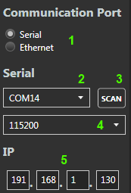

Figure 2 Communication Options

1. Click the **BREAK**button to determine if the ADCP can communicate with the application. In the terminal window, you should see some data output.



Figure 3 Communication Buttons

1. Click on the Recover button (2). This will bring you to the Recover page.



Figure 4 Navigation Menu

1. On the Recover page, click the “Populate List” button (1). Get a listing of all the files to download. Section 23 will list all the files to download. Select all the files to download. Then click the button “Download Data” (2) to download all the selected files. If you would like the data to be parsed to a MATLAB file after all the files are downloaded select the “Parse Data” (13).

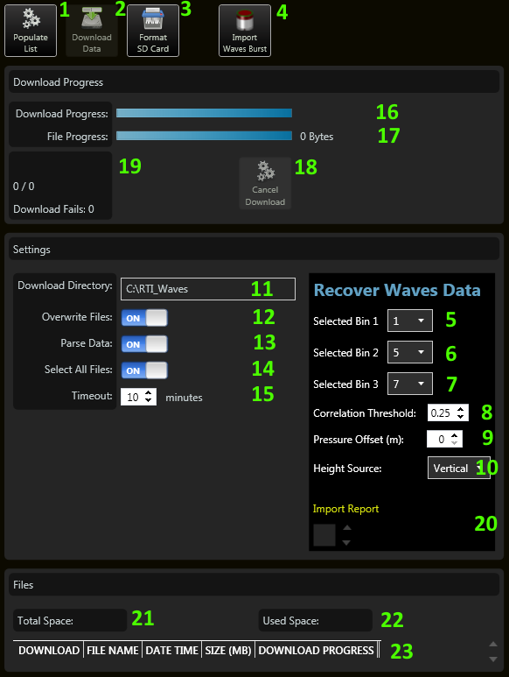

Figure 5 Recover Options

# Navigation Menu

This will describe all the menu items. The menu will allow you to navigate through the Pulse Waves software.



Figure 6 Navigation Menu

## Back Button

Go back to the previous viewed page.

## Configure Button

The configure page will allow the user to configure the ADCP for a waves deployment. This will include giving a prediction of deployment and sending and saving commands to the ADCP. Default options are also given to the user to allow the user to get some preconfigured options.

## Recover Button

The Recover page will allow the user to recover data from the ADCP. This will download the data to a computer and also convert the files to MATLAB files.

## View Button

The View page will allow the user to review the recorded data from the ADCP. This will display plots of a single burst and also all the bursts. The page will allow the users to select which files to playback and which files to display.

## Terminal Button

The Terminal page will allow the user to setup communication with the ADCP. The user can communicate with the ADCP through serial or Ethernet. This page will allow the user to set the correct connection settings and verify communication. It will also allow the user to send commands to the ADCP.

## Firmware Button

The Firmware page will allow the user to upgrade the ADCP’s firmware.

## Compass Cal Button

The Compass Cal page will allow the user to do a compass calibration on the ADCP. It is suggested to do a compass calibration within the environment that the ADCP will be used.

## WaVector Button

This button will load a dialog to select which MATLAB files to pass to WaVector to process and view. For this button to work, a file must be located in the directory C:\ProgramData\RTI\Pulse_Waves named WaVectorExe.txt. Within this text file, give one line for the executable path to WaVector application.

C:\ProgramData\RTI\Pulse_Waves\WaVectorExe.txt

C:\WaVector.exe

When the files are selected, it will create a text file in C:\ProgramData\RTI\Pulse_Wave\WaVectorSelectedFiles.txt. This file will contain all the files selected separated by a comma.

C:\ProgramData\RTI\Pulse_Wave\WaVectorSelectedFiles.txt

C:\File1.mat,C:\File2.mat,C:\File3.mat

The command that will be sent based off the example:

> C:\WaveVector.exe C:\ProgramData\RTI\Pulse_Wave\WaVectorSelectedFiles.txt

# Configure Page

This will describe the Configure page. The Configure page will allow the user to configure the ADCP for a wave deployment. There are default configurations a user can select or create custom configurations. A prediction model is also displayed to show the user the range, standard deviation, maximum velocity, memory and battery usage. The user can also zero the pressure sensor and set the ADCP time.

As you press the buttons, the buttons will turn green. This will be useful for troubleshooting. If the button is not green, then the step was not completed, either because it was not pressed or because the communication is not established.

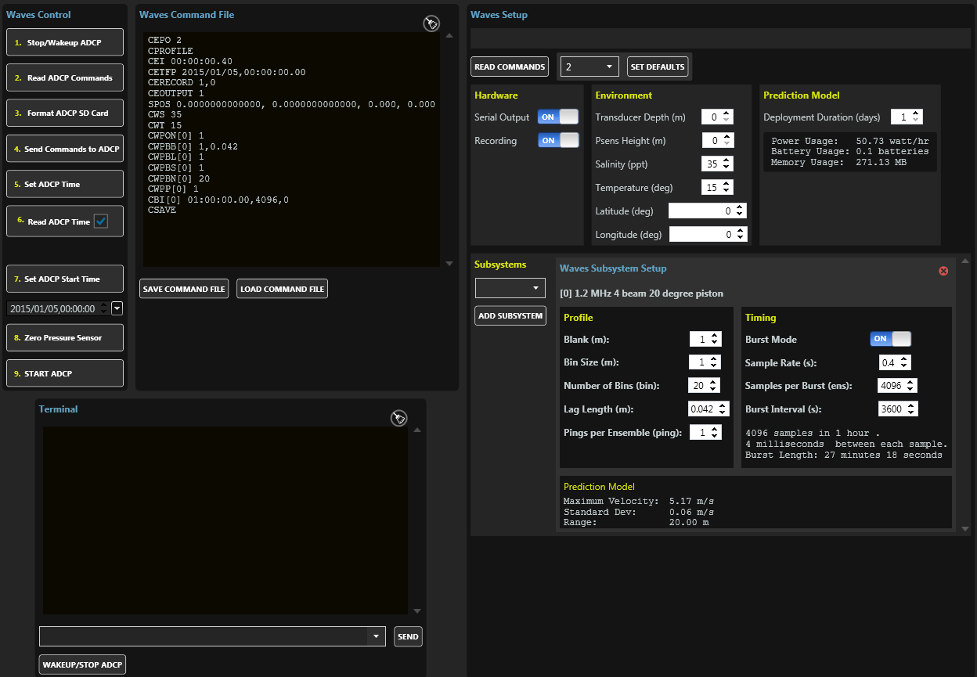

Figure 7 Waves Configuration

## Wave Controls

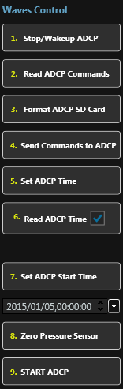

Figure 8 Wave Control Buttons

### Stop/Wakup ADCP Button

Wakeup or stop the ADCP pinging. This will send a BREAK and a STOP command to the ADCP. This will wakeup and also stop the ADCP from pinging.

### Read ADCP Commands

Read in the current settings of the ADCP. This will determine how the ADCP was configured. This can be helpful to see what settings such as the bin size or number of pings were used in the previous deployment so you can change or reuse the previous deployment settings. This will also check the

### Format ADCP SD Card

This will format the internal SD card on the ADCP with DSFORMAT command. This will delete the previous deployment. Ensure it is ok to erase all the previous data on the ADCP.

### Send Commands to ADCP

Send all the commands set in the “Wave Setup” options to the ADCP. This will use all the commands found in the “Waves Command File” box. You can manually add additional commands in the “Waves Command File” if the “Wave Setup” section did not include an option.

### Set ADCP Time

Set the time to the ADCP with the STIME command. This will use the time based off the computer. If you would like to use a different time, you can always use the “Waves Command File” section. The ADCP time is necessary to know when to start pinging and for time stamps for the data.

### Read ADCP Time

Read the ADCP time by sending the STIME command. This will read the ADCP date and time to verify it was set correctly. It will be displayed below the button.

If the check box is set, it will set the time for the CETFP to the current time read in the “Waves Command File”. This will cause the ADCP to begin pinging immediately when the “START” command is sent. This will also set the “Set ADCP Start Time” value.

### Set ADCP Start Time

Set the time when the ADCP should first wakeup and begin the pinging process. The value for the time will be taken from the textbox below the button. The date and time can both be set in the textbox.

### Zero Pressure Sensor

Zero the pressure sensor by sending the CPZ command. This will zero the pressure sensor to the current environment. If this is not a good place to zero the pressure sensor, this command can be sent at a later time.

### Start ADCP

This will send the START command and begin the pinging process. If the CETFP command was sent to a future date and time, the ADCP will go to sleep until the date and time is met. If the CETFP is the current date and time or the past, the ADCP will begin pinging immediately. Depending on the settings, you may be able to see the data output through the serial port.

## Wave Setup

This section will allow you to configure the ADCP for a wave deployment. As the options are changed, the “Waves Command File” will be updated. There are default settings that the user can select based off the system type selected. A prediction model will also display how the ADCP will perform based off the options.

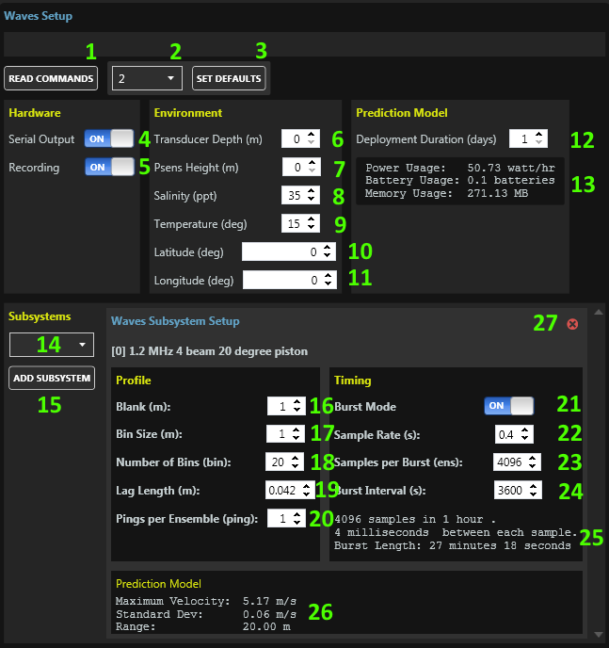

Figure 9 Waves System Configurations

### Read Commands

Read in all the commands from the ADCP. There will determine how the previous configuration of the ADCP were set. It will then set all the options based off what was read.

### Default Subsystem Options

Select the Subsystem that best matches your ADCP. The combobox will give the subsystem code and description. The subsystem code can be found in the ADCP serial number. The 8 digits after the first 2 digits in the serial number are the subsystem code.

### Set Defaults

After the selecting the subsystem in (2), click the “Set Defaults” button to set the default options. This will set all the default options. Any previous settings will be lost once this button is clicked.

### Serial Output

*CEOUTPUT*

Turn this on if you would like data to be output through the serial port when data is available. The data can then be recorded through the serial port. If you do not plan to record data through the serial port or do not need to see live data, it is better to turn this off to save power.

### Recording

CERECORD

Turn this on to record data to the Internal SD memory card within the ADCP. When this is on, the wave data will be recorded to the internal SD card. Make sure you format the SD card before starting a new deployment by sending the DSFORMAT command or pressing the “5. Format ADCP SD Card” button.

### Transducer Depth

*SPOS*

This will set the depth of the transducer below the surface of the water in meters. This is used to know the environmental settings of the ADCP.

### PSENS Height

*SPOS*

This will set the Pressure Sensor Height. This will set the depth of the pressure sensor height below the surface in meters. This is used to know the environmental settings of the ADCP.

### Salinity

*CWS*

This value is the salinity of the water. Default values for the ocean are 35 ppt. Default values for fresh water are 0 ppt. This value is used to calculate a proper speed of sound value.

### Temperature

*CWT*

This value is the temperature of the water in degrees Celsius. The default value is 15 degrees Celsius. This value is used if thermistor is not installed in the ADCP or if the value is bad. This value is used to calculate a proper speed of sound value.

### Latitude

*SPOS*

Latitude position in decimal degrees. This is used for reference only.

### Longitude

*SPOS*

Longitude position in decimal degrees. This is used for reference only.

### Deployment Duration

This value is used for the prediction model to calculate the data and power usage. The value is in days. Select the number of days. As the value is updated, the prediction model will be updated.

### Prediction Model

This will give the power usage, battery usage and memory usage based off the options and deployment duration. As the options for the ADCP and deployment duration are changed, the prediction will automatically update.

**Power Usage**: The power consumed by the ADCP based off the options and the deployment duration.

**Battery Usage:** The battery usage is based off power usage and a standard alkaline battery rated at 440 Watt-Hr from 38C batteries.

**Memory Usage:** The amount of data that will be stored to the internal SD memory card based off the ADCP options and the deployment duration. To reduce the amount of memory usage, reduce the number of bins and also turn off Bottom Track if you are not using it.

### Subsystem Selection

Select an additional subsystem to add to the configuration. The available selections are based off the serial number. Only subsystems within the serial number can be selected. Once a subsystem has been selected, click the “Select Subsystem” button to add it to the configuration. The subsystem will be added to the *CEPO* command.

Click the “Read Commands” button to restrict the subsystems to only those available based off the serial number. If the serial number is unknown, then all the subsystem types will be available. Choosing a subsystem not available to the ADCP will cause issues.

### Add Subsystem Button

This will add the selected subsystem to the configuration. This will allow the user to configure the ADCP differently between each configuration. Once the pinging begins, the ADCP will collect data for all the configurations.

### Blank

*CWPBL n.nn*

Water Profile Blank (meters). n.nn = 0 to 100. Sets the vertical range from the face of the transducer to the first sample of the first bin.

### Bin Size

*CWPBS n.nn*

Water Profile Bin Size (meters). n.nn sets the vertical bin size.

### Number of Bins

CWPBN n

Water Profile Bin N. n = 0 to 200 sets the number bins that will be processed and output.

### Lag Length

CWPBB 1, 2, 3, 4

Lag length in vertical meters (m).

* 1. Not used with Narrowband.
  2. A longer lag will have lower variance and a lower ambiguity velocity.

### Pings per Ensemble

*CWPP n*

Water Profile Pings. n = 0 to 10,000 sets the number of pings that will be averaged together during the ensemble.

### Burst Mode

Select to ping in burst mode or standard pinging. Typically for a wave deployment, burst mode will be used. Burst mode will collect a fixed number of pings over a period of time, then go to sleep. Standard mode will ping at a fixed interval continuously.

Burst mode will ask how many ensembles to collect and how long between each ensemble to wait and how often to collect data (*CBI)*.

Standard will ask how long to wait between each ensemble (*CEI)* and each ping (CWPTBP). Typically multiple pings will be collected and averaged together (*CWPP)*.

### Sample Rate

*CEI HH:MM:SS.hh*

Ensemble Interval. Sets the time interval that system will output the averaged profile/bottom track data.

Note: all digits including the space following CEI and the separators must be part of the command or the system will reject it.

### Samples Per Burst

*CBI*

Sets the number of ensembles that are output during each burst. The time between each ensemble is controlled by the CEI command.

### Burst Interval

*CBI*

HH:MM:SS.hh sets the time interval between a series of ensembles.

### Time Between Pings

*CWPTBP n.nn*

Water Profile Time Between Pings. n.nn = 0.00 to 86400.00 seconds (24 hours) sets the time between the last ping, regardless of ping type, and the next profile ping.

### Time Between Ensemble

*CEI HH:MM:SS.hh*

Ensemble Interval. Sets the time interval that system will output the averaged profile/bottom track data.

Note: all digits including the space following CEI and the separators must be part of the command or the system will reject it.

### Timing Model

Display the expect ping timing and number of pings based off the options set by the user.

### Prediction Model

Display the expected performance of the ADCP based off the options set by the user. This will include the maximum velocity that can be measured, the standard deviation and the maximum profiling range.

### Delete Subsystem

Remove the selected subsystem from the configuration. Each subsystem will have their own settings. Multiple subsystems can be added to the ADCP. This will allow the user to remove a subsystem.

## Waves Command File

This section will display the commands that will be sent to the ADCP. The user can add additional commands to this sections. The commands and values are determined based off the options set in the “Wave Setup” section. The user can also save or load a command file.

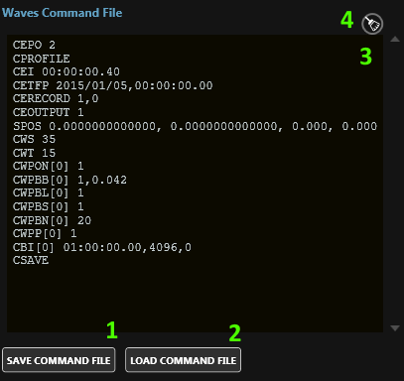

Figure 10 Wave Command File

### Save Command File

Save the values above to a text file. This will allow the user to save the settings for future use and also for historical purposes. The commands will be saved to the folder: c:\RTI_Configuration_Files. The file name will include the current date and time.

### Load Command File

Read in a command file and load the settings into all the options. The command file must list the commands the same way you would enter it in the terminal.

### Commands

This section gives a listing of all the commands that will be sent to the ADCP. At any time the user can add additional commands to this section. The values are generated based off the options set. If the user changes an options, this section will automatically updated.

### Clear Button

This will clear all the commands from the textbox. This is useful if you want to start out with a fresh set of commands. After clearing the commands, change any of the options and the commands textbox will be updated.

# Recover Data

This page will allow the user to download the latest data from the ADCP and also convert and binary data to a MATLAB file to be read into Wavector.



Figure 11 Recover Data Page

### Populate List Button

This will populate the list with all the available files to download from the ADCP.

### Download Data Button

This will begin the download process. This will only be available after the list is populated with the available files to download.

### Format SD Card Button

Format the internal memory. This will cause all recorded data to be erased. This will also cause any additional files uploaded to the ADCP to be deleted. Only the firmware files will remain.

### Import Waves Burst Button

This button will allow the user to select B Wave burst files created by the ADCP during Burst pinging and convert them to a MATLAB file. The burst files are just binary ensembles collected by the ADCP. These files are usually collected in batches of multiples of 1024. The files are generated in the ADCP using the CBI command. This button can also take standard binary ensemble files, but when stitching the data together in the plots, the data will not correct.

### Selected Bin 1

First selected bin to collect data. When the MATLAB file is generated, this bin will be used to generate the data.

### Selected Bin 2

Second selected bin to collect data. When the MATLAB file is generated, this bin will be used to generate the data.

### Selected Bin 3

Third selected bin to collect data. When the MATLAB file is generated, this bin will be used to generate the data.

### Correlation Threshold

When the data is being extracted from the binary data, this threshold is used to determine is good or if the data should be flagged as bad data in the MATLAB file.

### Pressure Offset

If there is a known pressure offset, this value can be used to add to the pressure value. If no pressure data is used, this can also be used to force a pressure value.

### Height Source

Select the source to give the wave height, other than the pressure sensor. The user will choose between one of the beams, or the vertical beam. This will be stored with the MATLAB file.

### Download Directory

Download the data to this given directory. When the download begins, all the data from the ADCP that are selected to download will be stored to the directory. Make sure the folder chosen has the proper permissions to allow files to be added.

### Overwrite Files Switch

If the files already exist in the folder path, this will determine if the file will be overwritten. If set on, the file will be overwritten. If set off, if the file name exists in the folder, the file will not be downloaded. Even if the file sizes are different, the file will not be downloaded.

### Parse Data Switch

When downloading the data, the data can be parsed to a MATLAB file while being downloaded. By turning this setting on, the data will be parsed. This will increase the download time. But after the file downloaded, the files will need to be imported to create a profile file. By turning this setting on, you eliminate the need to import the data.

### Select All Files Switch

This gives a quick way to select or deselect all the files to download.

### Timeout

This is the amount of time allotted to download a single file. If downloading a file will take longer than this, then this value will need to be adjusted. This timeout is used to ensure all the files are downloaded and if a file hangs in the download process, it will attempt to move to the next file. The timeout can be reached if the baud rate is set low or if the file is very large and could take more than the timeout time to download the entire file.

### Download Progress

This gives the current download process. It states how many files will be download, how far into the download process a file is and how many files remain to be downloaded.

### File Progress

This give the progress of downloading all the selected files. As a file has completed downloading, this progress will move until all the selected files have completed downloading.

### Cancel Download Button

Cancel Download process. If the download process has begun, this will allow the user to cancel to the download process.

### File Status

This will give the status of the downloading progress. As the files are downloaded, if there are any errors, this status will report how many files failed the download progress. Failures can occur if communication is lost or a timeout occurs if the file is too big.

### Import Report

As the file is imported and parsed, the report will be updated with the latest report of the wave data. This will display all the waves files found and parsed.

### Total Space

This will display how much space is available in the ADCP’s SD card.

### Used Space

This will display the total spaced used in the internal ADCP’s SD card.

### Download File List

List of all the files to download. This will display the files, the size and the progress of the download.

# View Data

This allow the user to view the MATLAB data created by the Pulse Wave software. The plots will display the different aspects of the wave data. Most of the plots refer to a single burst period. The top 3 plots refer to the entire timespan of the wave deployment.

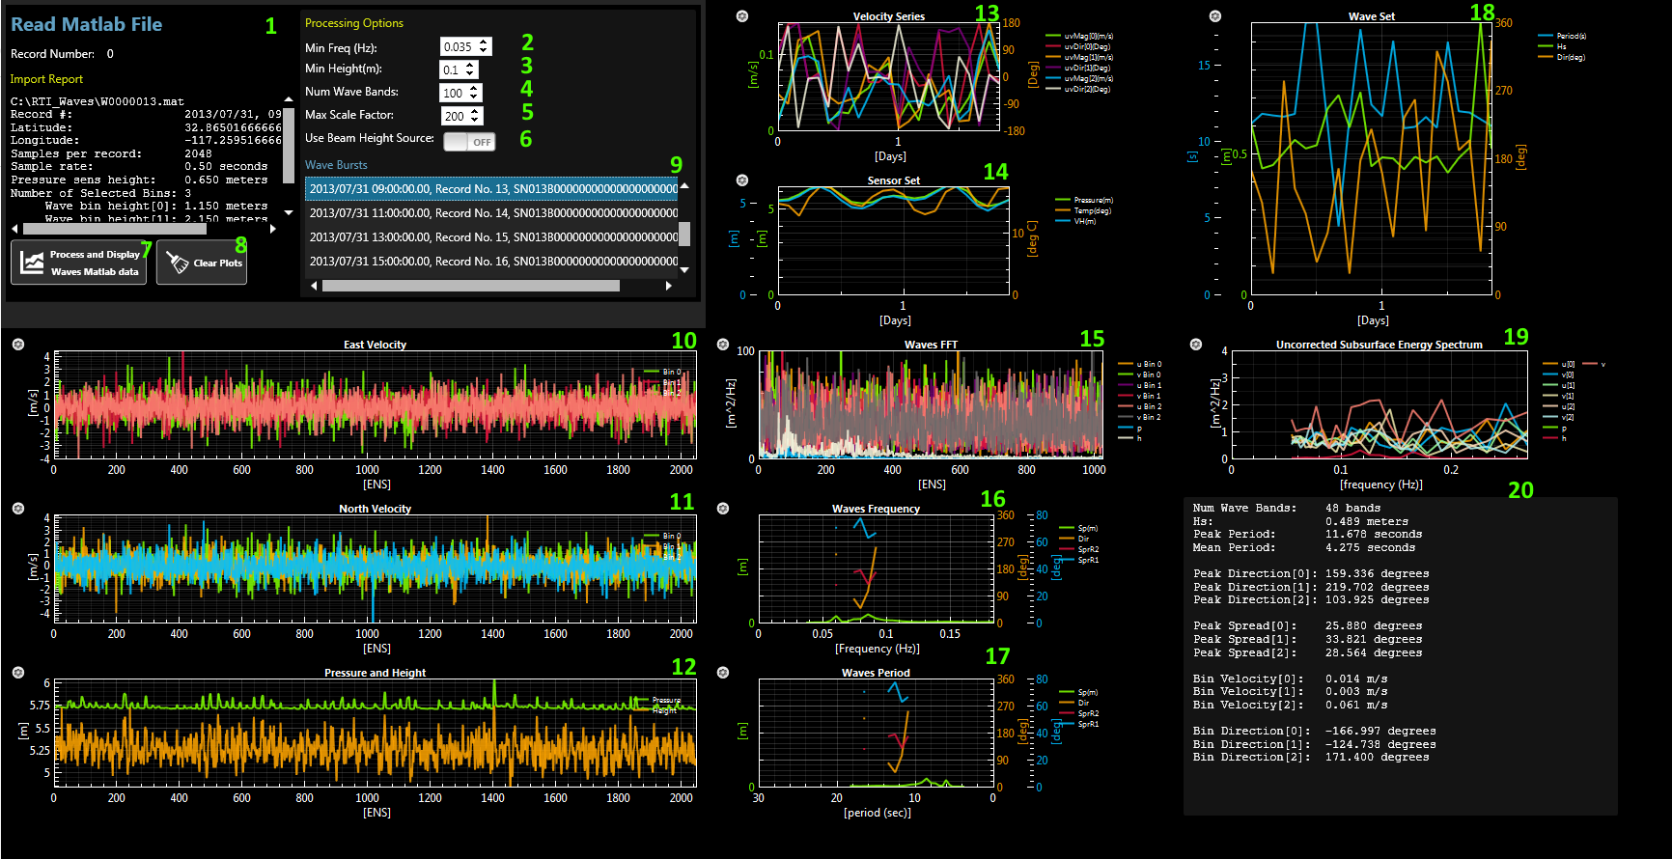

Figure 12 View Page

## MATLAB Report

When a MATLAB file is selected from the list, this section will display the information about the MATLAB file. The date and time the data was recorded. The location the data was collected. The number of samples per MATLAB.

## Min Freq

The minimum frequency to allow for the frequency calculations.

## Min HEight

The minimum height to allow in the height calculations.

## Num Wave Bands

Maximum number of wave bands to calculate.

## Max Scale Factor

Maximum value to use as a scale factor.

## Use Beam Height Source

Allow the beam data to be used as the beam height source.

## Process and Display Waves MATLAB Data

After pressing this button, the software will have the user select which MATLAB files to display. The files selected will be added to the list. The plots are updated with the latest added files.

## Clear Plots

Clear the list of all the MATLAB files. This will also clear all the files.

## List of Wave Bursts

A list of all the wave bursts. This is a list of all the files imported. Each file can be selected to view the plot information.

## East Velocity Plot

Plot the east velocity values for the selected bins. These values are found from the Earth Velocity data in the binary data. The velocities are plotted for each sample at the selected bin.

## North Velocity Plot

Plot the north velocity values for the selected bins. These values are found from the Earth Velocity data in the binary data. The velocities are plotted for each sample at the selected bin.

## Pressure and Height Plot

Plot the pressure sensor data and also the height data. The height data is based off the height source chosen when the MATLAB file was created. It was either one of the 4 beams or the vertical beam.

## Velocity Series Plot

Plot the East/North magnitude and direction for each selected bin. The plot’s data is a combination of all the MATLAB files imported.

## Sensor Set Plot

Plot the pressure value, temperature and velocity height value. The plot’s data is a combination of all the MATLAB files imported.

## Waves FFT Plot

Plot the FFT east and north velocity data for each selected bin. Also plot the pressure and height values.

## Waves Frequency Plot

Plot the wave frequency data.

## Waves Period Plot

Plot the wave period data.

## Wave Set Plot

Plot the period, wave height and direction of the data. The plot’s data is a combination of all the MATLAB files imported.

## Uncorrected Subsurface Energy Spectrum Plot

Plot the wave spectrum data.

## Text Output

Display the textual data of the wave burst. It will display the mean and peak data. It also gives the velocity and direction for the selected bin.

# Terminal View

The terminal allow the user to communicate with the ADCP through a serial or ethernet connection. This can be used to send command and see data output.

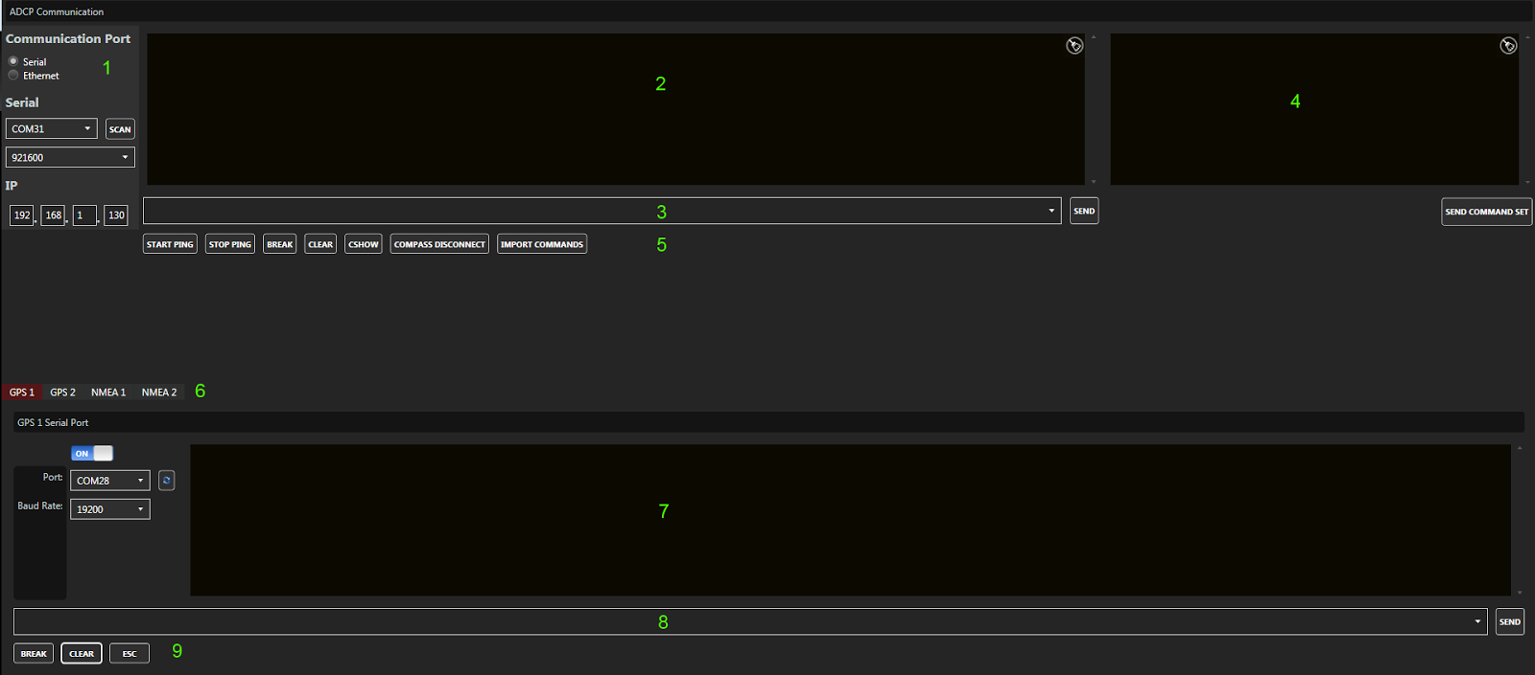

Figure 13 Terminal Page

## 1. Communication Ports

This will allow the user to select between using the ethernet or serial port to communicate with the ADCP. Not all the functions are currently supported in Pulse to communicate in ethernet mode.

The Ethernet pinging is done different from serial communication.  You must poll the ADCP for data.  A buffer within the ADCP is filled, when the ADCP is pinged through the ethernet, it will dump whatever is in the buffer.

The ADCP is not using UDP and is not a TCP/IP server.  You are really just pinging the ADCP and within the ping is a buffer with the command.  The ping will cause the ADCP to send a ping response and within the ping response is a buffer which contains the ADCP data.  The ping response is an "Internet Control Message Protocol (ICMP)" echo.

Any command sent through the ethernet must start with "*RTIy*".

The command must end with a carriage return (\r).

Example if you want to send a BREAK.

*RTIyBREAK\r*

To poll the ADCP for data you send a blank command.

*RTIy\r*

If you are writing your code in C#, you can find examples of this in the file:  
<https://github.com/rowetechinc/RTI/blob/master/Communications/AdcpEthernet.cs>

*CSHOW* will give the IP address of the ADCP.



Figure 14 Communication Port

#### 1.1. Port Option

Select between using the ethernet or serial port to communicate with the ADCP.

#### 1.2. Serial Comm Port

Set the serial port COMM port.

#### 1.3. Scan Button

This button will scan for any available COMM ports on the user’s computer.

#### 1.4. Serial Baud Rate

Set the serial baud rate.

#### 1.5. Ethernet Address

Set the ethernet address of the ADCP. The ethernet must be turned on the ADCP for the ethernet connection to work. Refer to the RTI ADCP DVL User Guide on how to enable the ethernet port.

Also make sure the user’s computer matches the address range as the ADCP. If they do not match, either change the ADCP’s ethernet address or change the user’s computer. For the addresses to be in the same range, the first 2 values should be the same on both the ADCP and computer.

## 2. ADCP Output

As data is received, you will see characters displayed in the terminal. The characters are not human readable unless the ADCP is set to DVL, ASCII or a special mode.

## 3. ADCP Input

This textbox allows the user to enter in a command to send to the ADCP. The textbox will remember passed commands. Once the command is entered into the textbox, press the send button to send it to the ADCP.

## 4. Additional Commands

This will allow the user to load a file of additional commands. It will also allow the user to reuse a set of commands.

## 5. ADCP Buttons

These buttons are common commands sent to the ADCP. They include starting and stopping pinging, sending a BREAK and a CSHOW.

### 5.1. Start Ping Button

This button will send the command to the ADCP set the current time to the ADCP and to start pinging. The current time is sent to so the ADCP has a date and time. Then the START command is sent to start pinging.

### 5.2. Stop Ping Button

This button will send the command to the ADCP to stop pinging.

### 5.3. BREAK Button

This button will send a BREAK to the ADCP. The BREAK is used to wakeup the ADCP. The ADCP will output a banner message when the BREAK is received.

First a hard BREAK is sent to the ADCP. A hard BREAK is a hardware BREAK. If no banner is received from the ADCP, a soft BREAK is sent to the ADCP. A soft BREAK is a software BREAK where the command BREAK is sent. If neither of these command wakeup the ADCP, then most likely there is an issue with the connection to the ADCP.

### 5.4. Clear Button

This button will clear the ADCP serial output display.

### 5.5. CSHOW Button

This button will send the CSHOW command to the ADCP. The CSHOW command should send a response back with all the commands and options from the ADCP.

### 5.6. Compass Disconnect Button

This button will send the command to disconnect the ADCP from compass mode. If the user is trying to talk with the internal compass, the user must go into compass mode. If the user does not properly exit out of compass mode, the ADCP will remain in compass mode. In compass mode, the ADCP will not function properly. This button will allow the user to exit out of compass mode if the ADCP was accidently left in compass mode.

## 6. GPS and NMEA Output Tabs

There are currently 4 tabs to choose from. Each tab refers to a different serial port for GPS and NMEA data. The user can set each of the 4 serial port to receive data from external devices. If the data is in NMEA format, the data will be added to the ensemble. The data will also be added to the project file. Each tab’s data can also be used for screening.

## 7. GPS and NMEA Serial Output

When the GPS is connected to the serial port, this will display all the output from the GPS. As data is received, you will see characters displayed in the terminal.

## 8. GPS and NMEA Serial Input

This textbox allows the user to enter in a command to send to the GPS. The textbox will remember passed commands. Once the command is entered into the textbox, press the send button to send it to the GPS.

## 9. GPS and NMEA Buttons

These are common buttons used to communicate with the GPS.

### 9.1. GPS and NMEA BREAK Button

This button will send a BREAK to the GPS.

### 9.2. GPS and NMEA Clear Button

This button will clear the GPS serial output display.

### 9.3. GPS and NMEA ESC Button

This button will send an ESC character to the GPS.

# Update Firmware

Upload the latest firmware to the ADCP. This will allow the user to upload any files including firmware to the ADCP’s internal memory. Press the “Update Firmware” button and select the file you would like to upload. Then press OK. Wait for the file to be uploaded to the ADCP.

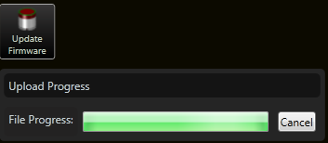

Figure 15 Update Firmware Page

# MATLAB File Format

This will give a description of all the variables in the MATLAB file format. Each MATLAB file will be a collection of ensembles called a burst. The number of ensembles within the burst is based off the CBI command. There will be 3 selected bins to collect the data from each sample (ensemble).

## TXT

This will give a text description of the burst. This will include the record number, the serial number and the date and time the burst started.

**Data Type**: Text

**Rows**: 1

**Columns**: Text Length

txt = 2013/07/30 21:00:00.00, Record No. 7, SN013B0000000000000000000000000000

## LAT

The latitude location where the burst was collected.

**Data Type**: Double

**Rows**: 1

**Columns**: 1

lat = 32.865

## LON

The longitude location where the burst was collected.

**Data Type**: Double

**Rows**: 1

**Columns**: 1

lon = -117.26

## WFT

First sample time of the burst. The value is in hours of a day. WFT * 24 = hours.

**Data Type**: Double

**Rows**: 1

**Columns**: 1

wft = 7.3545e+05

## WDT

Time between each sample. The time is in seconds.

**Data Type**: Floating Point

**Rows**: 1

**Columns**: 3

wdt = 0.50000

## WHP

Pressure sensor height in meters.

**Data Type**: Floating Point

**Rows**: 1

**Columns**: 3

whp = 0.65000

## WHV

Wave cell depth in meters. This is the wave height for each selected bin.

**Data Type**: Floating Point

**Rows**: 1

**Columns**: 3

whv =

1.1501 2.1501 2.6501

## WUS

East velocity values for each selected bin. The values are in meters per second.

**Data Type**: Floating Point

**Rows**: Number of Samples

**Columns**: 3

wus =

4.1217e-01 -5.3776e-01 -1.1071e+00

4.2764e-01 -8.8026e-01 -1.6288e+00

6.0827e-01 1.0991e-01 -2.0296e-01

…

## WVS

North velocity values for each selected bin. The values are in meters per second.

**Data Type**: Floating Point

**Rows**: Number of Samples

**Columns**: 3

wvs =

-6.5988e-02 9.4322e-01 -1.1511e+00

1.4117e-01 4.4475e-01 5.6886e-01

7.5457e-01 4.9238e-02 1.4024e-01

…

## WZS

Vertical velocity values for each selected bin. The values are in meters per second.

**Data Type**: Floating Point

**Rows**: Number of Samples

**Columns**: 3

wzs =

-5.1074e-01 -2.2284e-01 7.4548e-02

3.7416e-02 9.5439e-04 -2.1598e-01

1.5141e-01 -1.2996e-01 -9.9256e-03

…

## WB0

Beam 0 beam velocity values for each selected bin. The values are in meters per second.

**Data Type**: Floating Point

**Rows**: Number of Samples

**Columns**: 3

wb0 =

1.0128e+00 -1.2829e-01 7.5696e-04

3.6575e-02 -6.1568e-01 -4.6019e-01

-1.1937e-01 9.9974e-02 1.4221e-01

…

## WB1

Beam 1 beam velocity values for each selected bin. The values are in meters per second.

**Data Type**: Floating Point

**Rows**: Number of Samples

**Columns**: 3

wb1 =

8.2430e-01 6.1270e-01 -1.2160e-01

-7.7283e-02 6.0340e-04 8.8888e+01

4.6664e-03 8.4763e-02 3.0490e-01

…

## WB2

Beam 2 beam velocity values for each selected bin. The values are in meters per second.

**Data Type**: Floating Point

**Rows**: Number of Samples

**Columns**: 3

wb2 =

1.6416e-01 7.9276e-02 -5.0224e-01

8.9448e-02 6.6506e-02 -1.0250e-01

1.0159e-02 1.8974e-01 -2.5725e-01

…

## WB3

Beam 3 beam velocity values for each selected bin. The values are in meters per second.

**Data Type**: Floating Point

**Rows**: Number of Samples

**Columns**: 3

wb3 =

8.8888e+01 -5.1399e-02 5.8452e-01

-1.9667e-01 3.3825e-01 5.0058e-01

-6.3540e-01 1.0748e-01 -2.1207e-01

…

## WZ0

Vertical beam velocity values for each selected bin. The values are in meters per second.

**Data Type**: Floating Point

**Rows**: Number of Samples

**Columns**: 3

wz0 =

-5.6031e-01 -3.3704e-01 -5.7669e-01

8.8888e+01 -8.8736e-03 2.0687e-01

-9.9038e-01 -5.8064e-01 8.8888e+01

…

## WHG

The heading value in degrees for each sample.

**Data Type**: Floating Point

**Rows**: Number of Samples

**Columns**: 1

whg =

320.35

320.40

320.67

…

## WPH

The pitch value in degrees for each sample.

**Data Type**: Floating Point

**Rows**: Number of Samples

**Columns**: 1

wph =

-4.1934

-4.1980

-4.1989

…

## WRL

The roll value in degrees for each sample.

**Data Type**: Floating Point

**Rows**: Number of Samples

**Columns**: 1

wrl =

1.9210

1.9278

1.9021

…

## WPS

The pressure value in meters for each sample.

**Data Type**: Floating Point

**Rows**: Number of Samples

**Columns**: 1

wps =

5.9431

5.9438

5.9442

…

## WTS

The water temperature value in degrees fahrenheit for each sample.

**Data Type**: Floating Point

**Rows**: Number of Samples

**Columns**: 1

wts =

17.004

17.004

17.004

…

## WHS

The wave height based off the wave height source selected. This can be any of the 4 beams or the vertical beam’s value.

**Data Type**: Floating Point

**Rows**: Number of Samples

**Columns**: 1

whs =

5.2956

5.3744

5.4217

…

# Compass Calibration

This will allow the user to calibrate the compass within the ADCP.

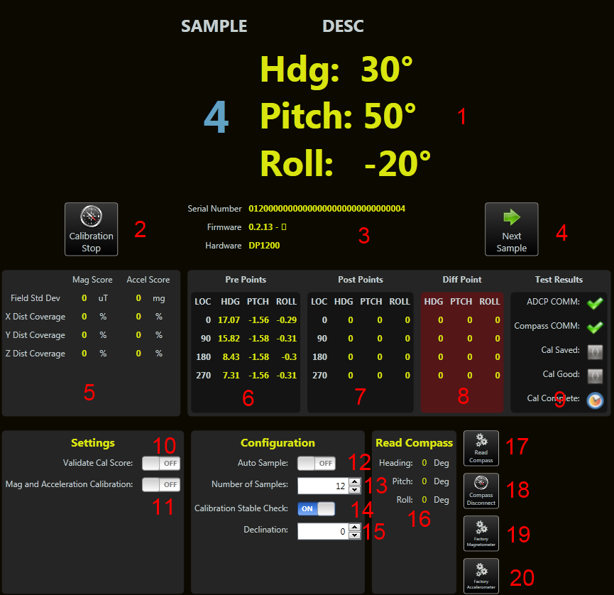

### 1. User Prompt

This is the location in the calibration where the user is given instruction in how to the place the ADCP for the next sample. At the very basic, a heading is given. For compass calibration, it will give a heading, pitch and roll.

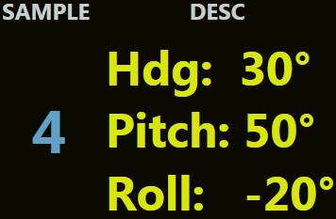

In this example, this is the 4th sample point. It is telling the user to have Beam 0 of the ADCP point to 30 degrees. Give a pitch of 50 degrees and a roll of -20 degrees. Once the ADCP is in this position, press the “Next Sample” button. When the compass reads this position, it will then move to the next sample.

### 2. Start/Stop Calibration Button

This button will allow the user to start or stop the compass calibration process.

**WARNING:**

**Stopping the Compass Calibration is very important to use if the calibration must be aborted. The ADCP is put in special mode and must be taken out of this mode for the ADCP to function properly.**

### 3. ADCP Info

This section give information about the ADCP. This will give the user feedback that an ADCP is found and that it is the proper ADCP to do the compass calibration to.

### 4. Next Sample Button

When performing the test, the user will need to tell the test when the ADCP is in the correct position to take a sample. The user will press this button when the ADCP is placed in the correct position. The compass will then take a sample and prompt from the next position.

### 5. Calibration Score

The magnetometer and accelerometer score are the score given by the compass. They are calculated based off the compass calibration. These scores are generated by the compass manufacturer. There are specs that the manufacturer has given for a good calibration also. The calibration score can also be used to determine if the calibration is good.

### 6. Pre-Points

These points are used to give a user feedback if the calibration was an improvement. When the pre points are collected, the user can see how far off the ADCP is in heading, pitch and roll. After the calibration, the post points are collected. Based off these points, you can see if an improvement was made or if the calibration made the heading worse. If the heading is more than 2 degrees off, then a calibration should be done again in a better environment. A good environment is one which is clear of magnetic material.

### 7. Post-Points

These points are used to give a user feedback if the calibration was an improvement. When the pre points are collected, the user can see how far off the ADCP is in heading, pitch and roll. After the calibration, the post points are collected. Based off these points, you can see if an improvement was made or if the calibration made the heading worse. If the heading is more than 2 degrees off, then a calibration should be done again in a better environment. A good environment is one which is clear of magnetic material.

### 8. Diff-Points

Diff points are the post points subtracted from the actual point. The difference is seen to verify if a calibration should be done again. Pitch and roll are subtracted by the pre and post points.

### 9. Test Results

This section is used to give the progress of the calibration process. It checks that a connection can be made to an ADCP. It then checks after the calibration that the calibration could be stored to the ADCP. It then verifies that the calibration was recorded to the maintenance file.

### 10. Validate Score Switch

This will use the Mag/Accel score to determine if the calibration was successful. This is for display purposes. The calibration will be still be performed and saved whether the scores pass or not. This will just give a warning to the user if the Cal scores fail.

### 11. Mag and Acceleration Calibration Switch

Perform both a magnetometer and accelerometer calibration. The accelerometer does not need to be calibrated for the ADCP to function properly.

### 12. Auto Sample Switch

Auto sample allows the user to perform the calibration without pressing the “Next Sample” button. When the compass feels the user has put the compass in a stable position, it will take a sample. The user can then move the compass to the next position and when it is stable it will take a sample. I have found when doing pitch and roll with the heading, the samples are taken before I am ready for the sample to be taken. When the calibration test begins, this options is turned off. It is then turned back on when the calibration is complete.

### 13. Number of Samples Input

The calibration allows between 12 and 24 samples to be taken for a calibration. The more samples taken, the better the result. The test works with only 12 samples.

### 14. Calibration Stable Check

When using Auto Sample, this will determine when the next sample should be taken. If this is turned off, then when the compass notices a stop, it will take a sample even if there is small movement going on.

### 15. Declination

If the user knows the correct declination for the location they are in, the user can set the declination for the compass.

### 16. Read Compass Section

To verify the compass is performing correctly, the “Read Compass” will allow the user to view the actual value seen by the compass. This makes direct communication to the compass to get a sample. To get a sample, press the “Read Compass” button.

### 17. Read Compass Button

This button will read a sample from the compass. This is used to verify the compass is performing correctly.

### 18. Compass Disconnect Button

If you abnormally stopped the calibration process, you will leave the ADCP in state where the compass will only output data. To put the ADCP back into a good state, you can press this button or the Stop Ping button on the serial port page.

### 19. Factory Magnetometer

Use the factory calibration for magnetometer. This is used when a good calibration cannot be accomplished.

### 20. Factory Accelerometer

Use the factory calibration for accelerometer. This is used when a good calibration cannot be accomplished.

# Compass Utilities

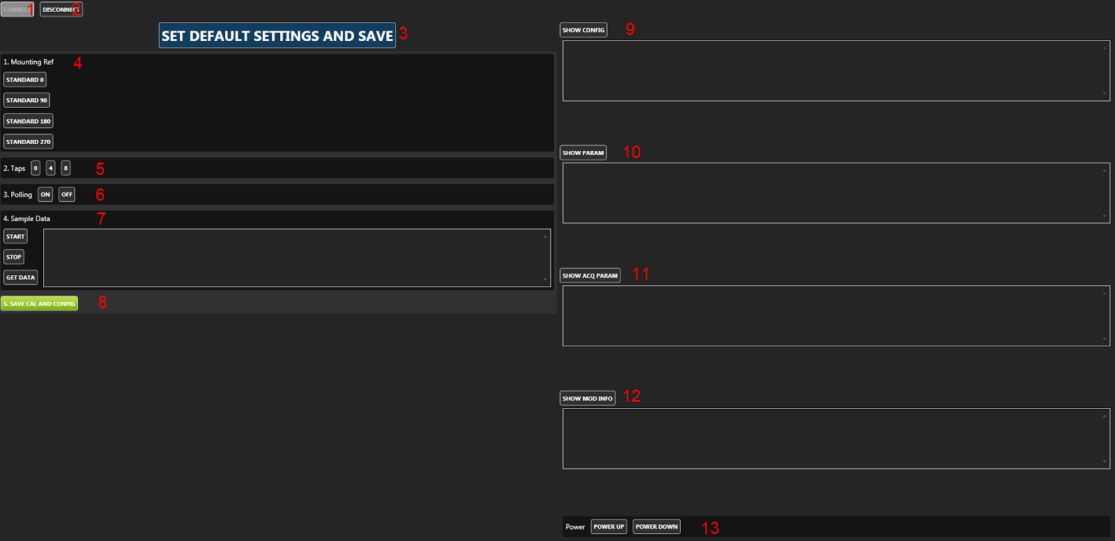

**WARNING:**

To communicate with the ADCP compass, the ADCP must be put in a special mode. This mode will relay all commands to the compass. But the user must also remember to take the ADCP out of compass mode when they are done. If you leave this view, it will automatically disconnect from the compass.

### 1. Connect Button

This button will connect the ADCP to compass mode.

### 2. Disconnect Button

This button will disconnect the ADCP from compass mode.

### 3. Set Default Settings And Save Button

This will set all the default compass values for the ADCP. This button is enabled only if the compass is connected. This button will do the equivalent of setting the mounting ref, taps, polling, sample data and hitting the save button.

### 4. Mounting Ref

This will set the mounting reference for the compass. This is the direction the compass will be pointed when moving forward.

### 5. Taps

This will set the taps for the compass. This has to do with filters and tables used for filtering.

### 6. Polling

This will set the polling on or off for the compass. When on, the user will need to ask the compass for a value. When off, the compass will output data automatically.

### 7. Sample Data

This will tell the compass to being outputting data continuously. Get Data will get a single sample.

### 8. Save Cal And Config Button

Once all the options have been sent to the compass, the configuration must be saved. This button will save all the configurations that are currently set in the compass.

### 9. Show Config

This will show the current configuration of the compass. This includes the declination, mounting reference and calibration settings.

### 10. Show Params

This will show the parameter of the compass. This includes the taps and the taps table.

### 11. Show Acq Param

This will show the acquisition parameters. This includes the polling mode.

### 12. Show Mod Info

This will show the compass’s firmware version and type.

### 13. Power

This will cause the compass to power down or up to save power.

# Compass Calibration Procedure

Below are instructions for performing both magnetometer and accelerometer user calibrations of the compass. These calibration sequences demonstrate a good distribution of the recommended minimum sample points: additional sample points may be taken.

Once calibration is complete the “Calibration Results” will indicate the quality of the calibration. This applies to both magnetometer and accelerometer calibration. The X, Y, and Z values show a percentage of each vector that has been covered during the calibration. For magnetometer calibration, a score of ≥85% is desirable for the X and Y vectors. The only way to get a Z value greater than 50% is to take calibration points with the unit upside-down as well as right-side-up. For accelerometer calibration, a score of ≥95% is desirable for the X and Y vectors, and ≥90% for Z vector. The values shown in μT for Mag Score and mg for Accel Score refer to the standard deviation of the measured samples when compared to the calculated values. The value for the Mag Score should be ≤0.1 and the value for the Accel Score should be ≤2.

At least 12 Calibration Points are required for the magnetometers to be calibrated, and at least 18 if the accelerometers or the accelerometers & magnetometers will be calibrated. The maximum number of calibration points allowable is 32, although generally the recommended number of calibration points is sufficient.

Select “Accel and Mag Calibration”, depending on which calibration procedure will be undertaken.

## 1. Magnetometer Procedure

• Hold the module level and stable.

• Click on the <Start Calibration> button and wait for a sample to be taken.

• Rotate the module to the next pattern position and hold the module stable until the next sample is taken.

• Repeat this until all samples, as set above, are taken.

• Click on the <Save Current User Cal> button

*Note: Once you begin taking calibration points, pausing between desired calibration points will cause unintentional points to be taken with auto sampling enabled.*

**Module approximately level**

• 0° yaw

• 90° yaw

• 180° yaw

• 270° yaw

**With module pitched positively ≥ 10 deg (recommended +50 degrees)**

• 30° yaw with small negative roll

• 120° yaw with small positive roll

• 210° yaw with small negative roll

• 300° yaw with small positive roll

**With the module pitched negatively ≥ -10 deg (recommended -50 degrees)**

• 60° yaw with small positive roll

• 150° yaw with small negative roll

• 240° yaw with small positive roll

• 330° yaw with small negative roll

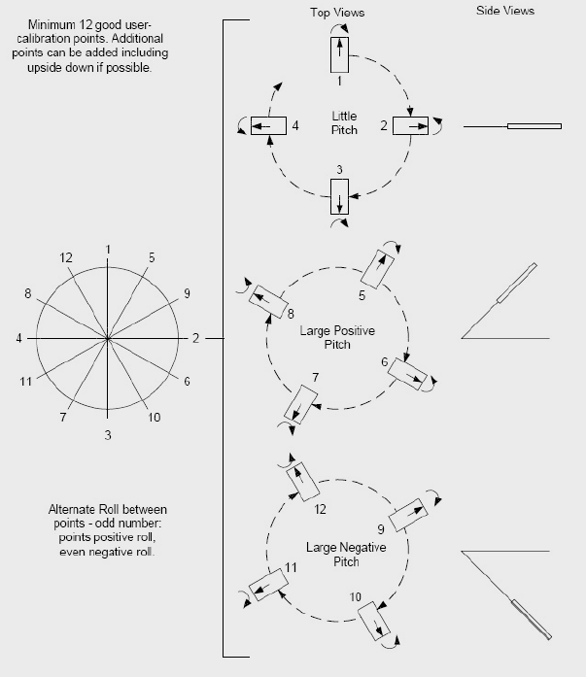

## 2. Accelerometer Procedure

The requirements for a good accelerometer calibration differ from the requirements for a good magnetometer calibration. For instance, a level yaw sweep, no matter how many points are acquired, is effectively only 1 accelerometer calibration point. PNI recommends an 18 point (or more) full range calibration pattern for the accelerometer, as described below.

• Figure below shows the two basic starting positions for the accelerometer calibration. Calibration can occur within the user’s system or with the module alone. It is not necessary for the module to be placed on a hard surface as shown, but the gravitational vector (relative to the module) must be as shown. Also, the module must be held still during calibration, and holding it against a hard surface is one method to help ensure this.

• Using the module as shown on the left, rotate the module such that it sits on each of its 6 faces. Take a calibration point on each face.

• Using the module as shown on the left, rotate it 45° such that it is standing on one of its corners, as shown for the module on the right. The picture shows the module also rotated about its Z axis, but this is only for illustration purposes. Take a calibration point (0°). Now tilt the module back 45° and take another calibration point (+45°), then tilt the module forward 45° and take another calibration point (-45°). Repeat this 3-point process by holding the module on each of its 4 corners.

• Note that the 18 calibration points can be obtained in any order.

